PROJECT PLAN: GROUP 12

Authors: All group members
Config Ref: ?
Date: 28/10/2013
Version: 1.0
Status: To review

CONTENTS

(Contents go here)

INTRODUCTION

1.1 Purpose of this Document

This document is here to ensure that the application we intend to build, a walking tour creator application for android, fully meets the requirement specification, as given by the client. It will help make sure that we cover all necessary features and that a quality product in produced.
This document will also outline how parts of the application will interact, along with how the user interface will actually look. As well as this, the document will highlight the project schedule, showing the major tasks to be completed, along with when each task needs to be achieved by. This will be displayed in the form of a Gantt chart.

1.2 Scope

This document should be read by the client, with reference to the requirement specification to ensure that what we intend to build meets what they expect us to build.
This document contains the following sections:

Use case diagram: This will show how every part of the program will interact and the links that must be in place for successful operation.

User interface design: This section will show how the finished application will look, as well as giving an idea of how it will feel to use. It will help ensure that the navigation and use of the app is simple, but suitable.

SYSTEM OVERVIEW

Gantt chart: In this section the major tasks will be made clear, along with when each task needs to be started and completed.

Risk analysis: This section stands to outline the possible problems we may encounter throughout this project, and how these problems can be avoided or solved.

1.3 Objectives

This document is here to show our preliminary plan for the proposed system and show that we have interpreted and understood the clients requirement specification.
The objectives this document has are:

- To give an summary of the project and the procedures, technologies and languages we will be using.
- To show the how each main part of the project with join together and interact.
- To display what we aim for the user interface to include, as well as how it will look when finished.
- To give a plan, with a schedule, of the tasks and milestones that need to be accomplished throughout the project.
- To highlight and understand possible issues with the project, and avoid them where feasible.
USE CASE DIAGRAMS

1.1 Android use case

Figure (INSTER FIGURE NO) shows the use case diagram for the android client. It describes the functions that the user will be allowed to use on the android app and a description of what each function does.

Facebook login

Register

login
Add Location

edit walk

New Walk
Cancel walk

User android side
Save walk

View Walks

Delete
walk
Quit app

Figure (Insert name and NO)

Log in
If the app is running for the first time on the device, a choice will be given to the user to register or sign in. Upon signing in a login request is sent to the server and a value of 0 or 1 returned. If authenticated, the user can then access the full application. If the authentication has failed a fail message will appear and prompt the user retry or to register. If re-try is selected they will be returned to the log-in screen, if register is selected then they will be referred to the Register User page.
Register User
The user will be shown a screen asking for details such as a user name, password and email address. Both the email address and password will then be encrypted when the submit button if pressed and a request will be sent to the server to check that the details don't conflict with existing data in any of the tables. The server will then return a token. Depending on the token a message box will warn the user that the information already exists and asked to change that field or that the information was correct and a new account has been created for them.

Record new walk
When a new walk is selected the user will be asked to enter information about the walk such as the walk name and a short description. When the user confirms the information inputted a snapshot of the time and GPS location will be taken and a request will be stored locally on the device.

Add point of interest
When the user adds a point of interest a location description, name will be asked for. An integer will be stored for the order of locations, the Lat and long co-ordinates and the date and time. The user will then be given a choice to take a photo or enter Audio, both of which will also be stored locally.

Cancel recording
If the recording is cancelled the data stored locally on the device will be removed, a message will notify the user that the walk has been cancelled.

Save recording
When the walk is complete and the user saves the walk then they will be asked for a long description of the walk and the user has checked and confirmed the information all the data will be sent to the data base. If no connection can be made then a message will appear warning the user that it could not connect to the server. If a successful connection is made, a request will be sent to the server to add the local information to the database.
The server will then return a token of 1 or 0. If Successful the local data will be removed otherwise a warning will tell the user that there was an error with the server and to try later and keep the local data stored to the device.

Review walk
The user will be given the option to review a walk. A request will be sent to server and a list box will be populated with the names of walks. When a walk is selected a map will be loaded with simple walk details, such as name, description, stat location etc. The user will be able to zoom in and out and look at the locations of the walk and be able to select that as a walk. If a walk is selected the full walk details will be requested from the server.

Delete walk
If a user is not happy with walks that they have recorded they will be given the choice to delete the walk from a drop box. A request will be sent to server to remove the walk from the database. The server will return a value and a message will appear telling the user if it was successful or not.

1.2 Web use case

Below describes the interactions the client program has with the server. It does not describe the
administrative functions, since these will probably be performed by a special, direct client. Note: Although there is a little figure of a person on the diagram, this is actually two programs talking to each other.

Register

Change walk information
login

edit walk

view my walks

delete walk

search walk

client web side

Logout

Figure (Insert Name and NO)

Register
A button will be on website will a user to register, a Message box will prompt the user for a username, password and email address. The email and password will then be encrypted and a request will be sent to the server. The information will then be check against other entries in the database. the server will then return a value. If the value is 0 then a message will be displayed and the user can then access other parts of the website. Depending on the token returned the user may get an error message asking to change a field that clashes with data already stored on the database, such as a username or email.
Login
A login button will allow registered users to enter the username and password. These will then be encrypted and a request will be sent to server to check the information. The server will then return a value. If the authentication is successful the user will be able to access information on walks that they have created. If it fails then they will be asked to retry or to register.

Edit
When the page loads a request is sent to the server to retrieve the information from the server. The user will be presented with a list box populated with their walks. When a walk is selected a request is made to the server to retrieve the full information about the walk, and a map should load with the details. The user should then be able to select points along the walk to add new locations etc.

Search
A search box will allow the user to search through the walks that other people have created with advance search options such as location, time etc.

View
An option to view the users walks will send a request to the sever for a list of walks that the user has made. A listbox will then be populated with the results.

Delete
The user will be able to look through of lists of walks that they have created and select one to be deleted. A message will prompt the user asking if they are sure they want to delete it, if the request is true then a request to the server will ask to remove all data stored related to that walk. The server will send a result confirming the deletion or an error why it couldn't.

OVERVIEW OF THE SYSTEM

1.1 Web Overview

PHP: Phone to database, interacts via MySQL.
MySQL – Connect to dcs.db.aber.ac.uk, allows information to be stored and retrieved for later use.
Connectivity – Phone must automatically acknowledge a loss in connection to either Mobile or WiFi services. If lost during an attempted retrieval or transmission of information. If unsuccessful then prompt the user a failed attempt at transfer, or return confirmation upon success. Store transmission information for return of connectivity?
Menu – Must Provide Registration and Login facilities as well as methods to look at the users paths, broken down into suitable categories.
Login – Must consist of a unique ID, username, password as bare minimum to be stored for the user credentials.
Must create necessary table to store login details.
Must create usable front end, easily used on mobile phone.

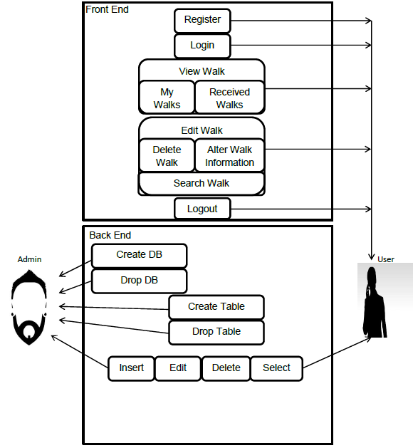
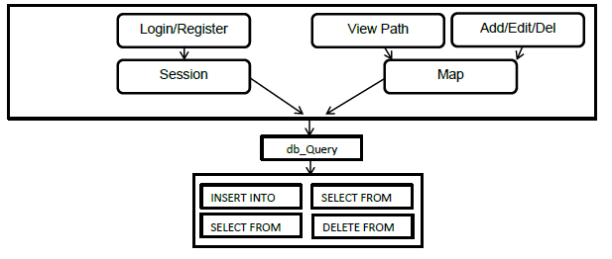
Figure (figure name here). Showing the diagram for the web overview of the system.
  - Android System Overview

The Application will use Google maps, and the android API

The diagram above (figure 1.2) shows how we propose the system to work. The proposed handheld application (front end) will be programmed in Java; making use of the Eclipse Android API.

The android application is expected to have the following:

Log In/Register

This is where users can create an account or use their existing account to access the program. The information the user passes to us here needs to get sent to the database to check to see if it is all correct information.

GPS Map View
This will allow the user to see where they are currently positioned on Google Maps. This is likely to
be automatically on screen as the user records a walk. When the walk is finished, they will be able to look at the map to see where they started and ended walking. An arrow or marker will point to any significant locations that the User has chosen to landmark on the way.

Local Walk Data
This is where walk information will be stored before the walk information such as Walk name, Journey time and the Descriptions of the walk has been sent to the database. This is important in case of a connectivity failure to prevent.

Uploading Walks
Users may select a walk to upload to the server. The entire data contained within the walk is synchronised with the database on the server.

Recording Walks
Users, while recording their walks will store information as local data on the handheld device. This prevents any information from being lost due to a connectivity error. Users will also be able to record walks offline due to this feature. Users will be able to take photos, choose significant landmarks and write descriptions about each walk here.

Editing Walks
User may change details about their walks before finally sending the information to the server. Here they can add a large description to their walk and can delete any walks they are unhappy with.

GUI Screens
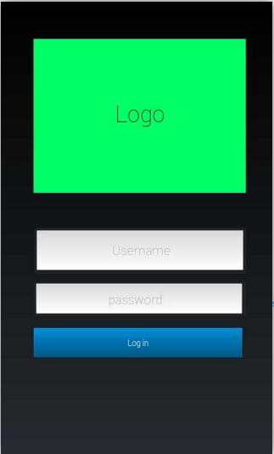
- Login screen (or some kind of credential system)

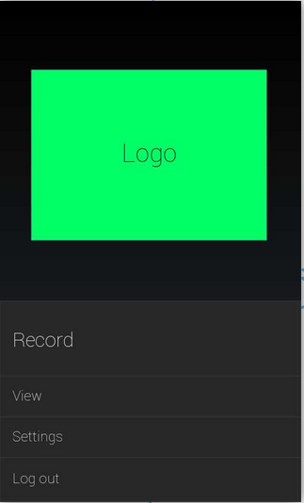
- Home screen - button for record walk - button for preferences/setting - button to look at the list of recently recorded walks

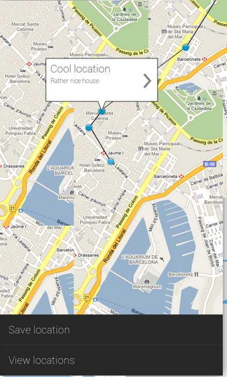
- Recording screen - map view - button to record location - potentially pause/unpause button
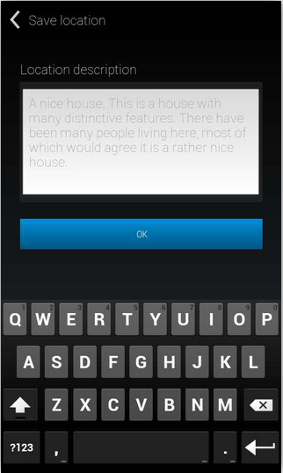
- Location recording screen - button to take photograph – button to record audio - small wizard prompting for each text entry

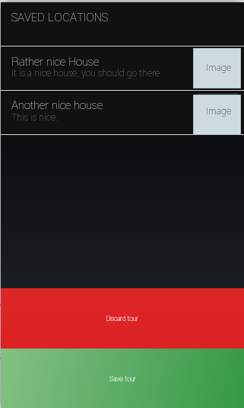

- Walk review screen - list of locations recorded - expandable map showing the walking trace - save button

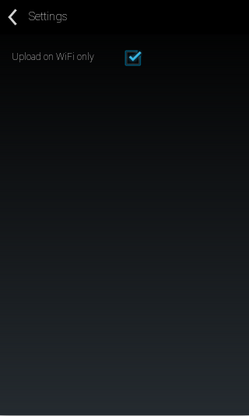
- Settings screen - some settings buttons - "only upload on wifi"

GANNT CHART(next page)

Preliminary Risk Analysis

Risk | Probability | Effects | Strategy
Loss of team member | Low | Serious | Reorganise team with more overlap of duty of each member.
Illness of team member | Moderate | Serious | Reorganise team with more overlap of duty of each member for the period of member illness.
.Documentation incomplete/late | Low | Series | Aim to complete parts of documentation well in advance of deadline. If problems occurs contact team members so that they can help to complete / fix errors.
Scale of Project underestimated | Low | Catastrophic | Produce project plan detailing the scale and scope of proposed system.
Requirement change | Low | Tolerable | Communicate with client. Communicate with group / project leader.Re-arrange project to incorporate feature making sure that it does not interfere with project dealine.
Loss of Project Leader | Low | Serious | Restructure team & reorganise duties with more overlap.

Life-cycle Risk Analysis
Risk | Probability | Effects | Strategy
Feature Creep | Moderate | Tolerable | Adhere to design spec. If problems occur the development team should communicate with the project leader.
Version control errors due to naivety. | High | Tolerable | Make sure that the version control expert fully trains each member of the team & that they understand proper Git use.
Loss of source code | Low | Catastrophic | Use a repository, have multiple backups. Contact project manager if does occurs.
Android Cross Platform Development Issues | Moderate | Tolerable | Agree on specific Android version that the development team will use.
Parts of system late or incomplete | Moderate | Serious | Adhere to gantt chart and try to complete well in advance of deadline. Communicate with project leader / team.
Parts of system defective | Moderate | Serious | Use proper testing strategies, e.g. blackbox / whitebox. Communicate with team to daft members in to help with fault finding.

Operational Risk Analysis
Risk | Probability | Effects | Strategy
Database performance | Low | Serious | Investigate better performing database.
Unresponsive UI - outlined in project spec. | Moderate | Serious | Investigate design patterns for responsive Android design.

